Kathala saddler

co-founder & director

BSC(Hons), IEng MCIBSE, LCC

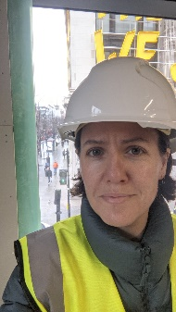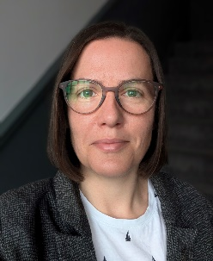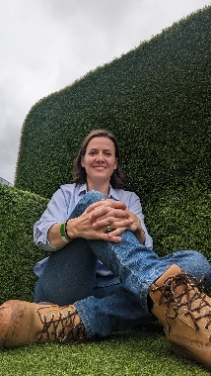

Contact: [kathala@fluentmep.com](mailto:kathala@fluentmep.com) / 07720642664 / [Linkedin](http://Linkedin) / [www.fluentmep.com](http://www.fluentmep.com/)

Introduction

Starting her career in building services as a CAD technician, Kathala has worked her way from a project engineer though to director level, most recently co-founding Fluent MEP with James Read. From the outset of her career, sustainability has been a primary motivator for Kathala, being able to influence the impact that a building has through the services design remains a source of great interest and a key driver for her.

In her previous role, Kathala moved from an Associate Director role in the southeast office of a UK wide consultancy to head up a new sustainability department within the same company. Building a team to develop the business offerings and providing support to both existing and new clients, with feasibility and decarbonisation plans and assisting with their net zero targets.

She is a well-versed mechanical design engineer demonstrating creative lateral thinking skill in design, whilst being commercially aware of projects to ensure solutions are viable both practically and financially. This is complimented by strong client relationship skills, ensuring clear and regular communications with the client and wider project team from feasibility and design, through to construction and handover.

Sector & Technical Experience

Since 2014 Kathala has held Low Carbon Consultant certification and continues to support clients in minimising energy use and reducing carbon emissions in both buildings design and operation, with a holistic approach to each project. Her experience covers a broad range of sectors, which in turn, has given her the opportunity to work in, and learn from, many different buildings. These include -

* Retail
* Educational
* Commercial
* Heritage/Listed
* Specialist
* Residential
* Mixed Use